DATA ANALYSIS PROJECT REPORT

Project Title
Student Outcomes Data Analysis

Abstract :
This project focuses on analysing student performance data to identify the key factors influencing academic outcomes. The dataset includes various attributes such as study hours, attendance, parental support, extracurricular activities, and final grades. Data cleaning and preprocessing were performed to handle missing values, remove duplicates, and ensure consistency. Exploratory Data Analysis (EDA) was conducted using SQL techniques such as aggregation, grouping, filtering, and subqueries to uncover meaningful patterns.
The analysis reveals that study hours, attendance, and parental support play a significant role in determining student performance. However, the results also indicate that high study hours alone do not guarantee better grades, highlighting the importance of balanced learning approaches. Visualizations and dashboards were created to better understand trends and relationships within the data.
The findings from this project provide valuable insights that can help educators and institutions improve student performance through targeted strategies. Overall, this project demonstrates the effectiveness of data analysis in solving real-world educational problems and supporting data-driven decision-making.

Introduction :
In today’s data-driven world, data analysis plays a crucial role in understanding patterns, trends, and relationships across various domains, including education. Educational institutions generate large amounts of data related to student performance, attendance, study habits, and other factors. Analyzing this data can help identify the key elements that contribute to academic success and areas where students may need improvement.
This project focuses on analysing student performance data to gain insights into the factors that influence final grades. The dataset includes important variables such as study hours, attendance, parental support, extracurricular activities, and demographic details. By applying data analysis techniques, it becomes possible to uncover hidden patterns and correlations within the data.
The analysis is performed using tools such as SQL for querying and data manipulation, along with visualization techniques to represent the findings effectively. Through this project, we aim to understand how different factors impact student outcomes and provide meaningful insights that can support better decision-making in the education sector.
Overall, this project demonstrates how data analysis can be used to transform raw data into actionable knowledge, helping educators and students improve academic performance.

Problem Statement :
Student academic performance is influenced by multiple factors such as study habits, attendance, parental support, and participation in extracurricular activities. However, it is often difficult to clearly identify which of these factors have the most significant impact on final grades. Without proper analysis, educational institutions may struggle to make informed decisions to improve student outcomes.
The main problem addressed in this project is to analyze student performance data and identify the key factors that influence academic success. This includes understanding the relationship between study hours and grades, the effect of attendance on performance, and how external factors like parental support and extracurricular activities contribute to student results.
By using data analysis techniques, this project aims to uncover patterns, trends, and correlations within the dataset. The goal is to provide actionable insights that can help educators and institutions develop strategies to enhance student learning, improve academic performance, and support students

Dataset Description :
The dataset used in this project contains information related to student academic performance and various factors that may influence their final grades. It consists of over 1000 records, making it suitable for meaningful data analysis and pattern identification.
Each record in the dataset represents an individual student and includes multiple attributes such as:
- Student ID – Unique identifier for each student
- Name – Name of the student
- Gender – Gender of the student
- Study Hours – Number of hours spent studying per week
- Attendance – Percentage of classes attended
- Parental Support – Level of support provided by parents (e.g., High, Medium, Low)
- Extracurricular Activities – Participation in additional activities (Yes/No)
- Previous Grades – Academic performance in earlier assessments
- Final Grade – Final score achieved by the student
The dataset is structured in a tabular format and was originally collected in CSV format. Before analysis, the dataset underwent cleaning and preprocessing to handle missing values, remove duplicates, and ensure data consistency.
This dataset provides a comprehensive view of both academic and non-academic factors affecting student performance, making it ideal for exploratory data analysis and insight generation.

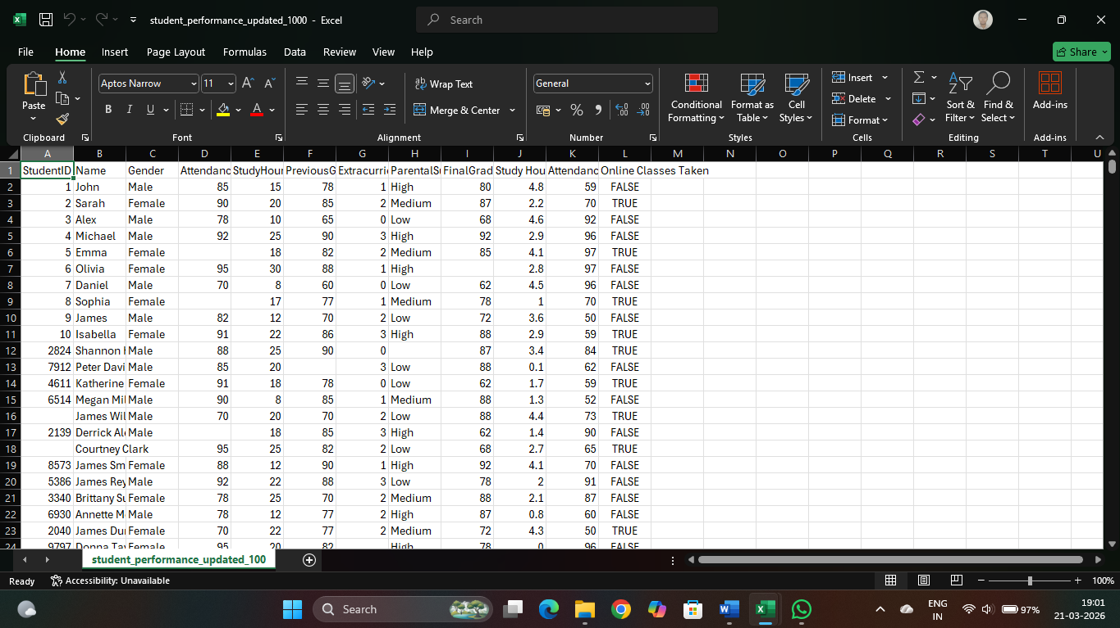

Data Cleaning Process :
Data cleaning is an essential step in data analysis to ensure accuracy, consistency, and reliability of the dataset. Before performing analysis, the student performance dataset was carefully pre processed using various data cleaning techniques.
The following steps were performed:
- Removed Duplicate Records
Duplicate rows were identified and removed to avoid biased or repeated analysis results.
- Handled Missing Values
Missing values in numerical columns such as Study Hours and Attendance were filled using the mean of the respective columns.
Missing values in categorical columns such as Gender and Parental Support were filled using the mode (most frequent value).
- Removed Duplicate Columns
Duplicate or unnecessary columns like repeated Study Hours and Attendance (%) were removed to simplify the dataset.
- Renamed Columns
Column names were standardized for better readability
- Corrected Data Types
Data types were checked and corrected. For example, Student ID was converted to the appropriate format, and numerical columns were ensured to be in integer or float format.
- Outlier Checking
Extreme values in columns such as Study Hours and Final Grade were reviewed to identify unusual patterns or errors.
- Data Formatting
Ensured consistency in categorical values (e.g., "Male/Female", "Yes/No") and removed extra spaces or inconsistencies.

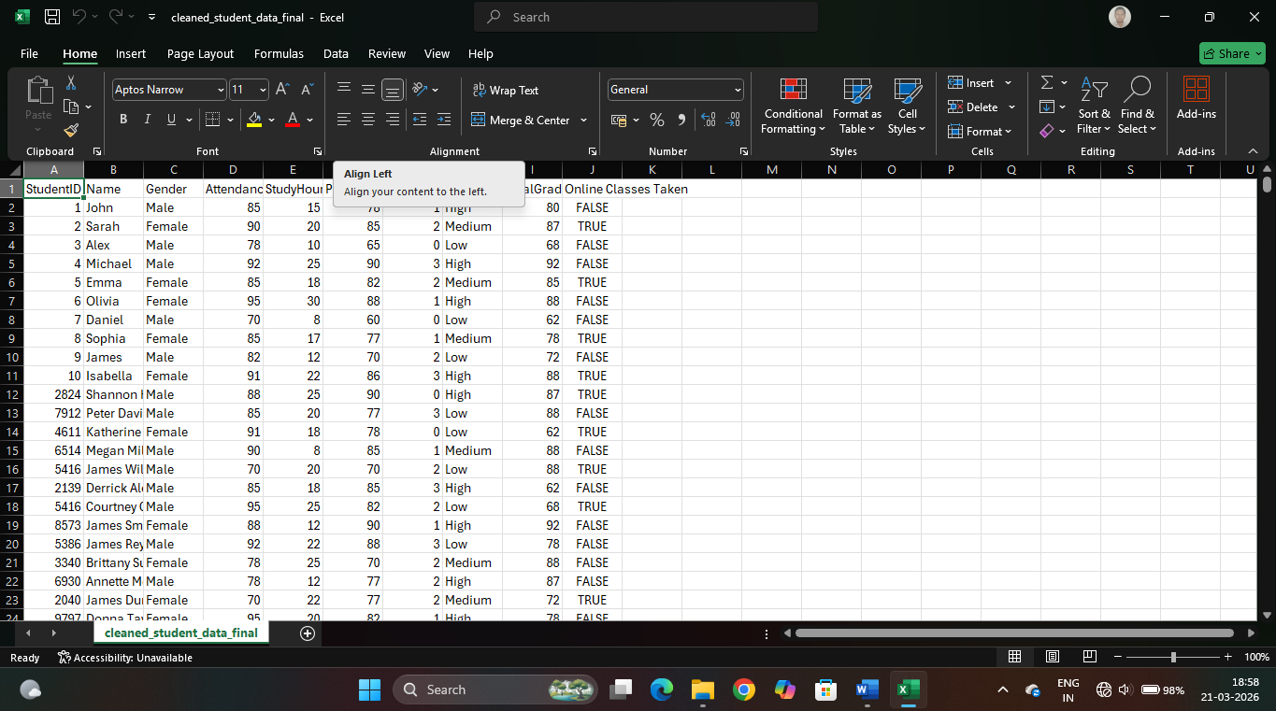

Exploratory Data Analysis (EDA) :
Exploratory Data Analysis (EDA) is performed to understand the dataset, identify patterns, detect anomalies, and extract meaningful insights. In this project, EDA was conducted using SQL queries to analyse relationships between different variables affecting student performance.
The following analyses were performed:
- Total Number of Students
The total count of students in the dataset was calculated to understand the dataset size.
- Average Performance Analysis
The average final grade and average study hours were calculated to get an overall view of student performance.
- Gender-wise Performance
Students were grouped based on gender to analyze if there is any significant difference in academic performance between male and female students.
- Parental Support Analysis
The dataset was analyzed to evaluate how different levels of parental support impact student grades.
- Study Hours vs Final Grade
The relationship between study hours and final grades was examined using grouping and filtering techniques. It helped identify whether increased study time leads to better performance.
- Attendance vs Performance
Students were grouped based on attendance levels to understand how attendance affects final grades. High attendance was generally associated with better performance.
- Top Performing Students
Students with the highest final grades were identified using sorting and limiting techniques.
- Above Average Students
A subquery was used to find students who scored above the average grade, helping identify high-performing individuals.
- Maximum Study Hours
Students who spent the highest number of study hours were identified to analyze their performance.
- Categorization of Attendance Levels
Attendance was categorized into High, Medium, and Low using conditional logic to simplify analysis and compare performance across categories.
- Extracurricular Activities Impact
The effect of participation in extracurricular activities on student performance was analysed.
- Special Case Analysis
Students with low study hours but high grades were identified to understand exceptional performance cases.
Overall, EDA helped uncover important trends and relationships in the dataset. These findings provided the foundation for generating insights and making data-driven recommendations in later stages of the project.

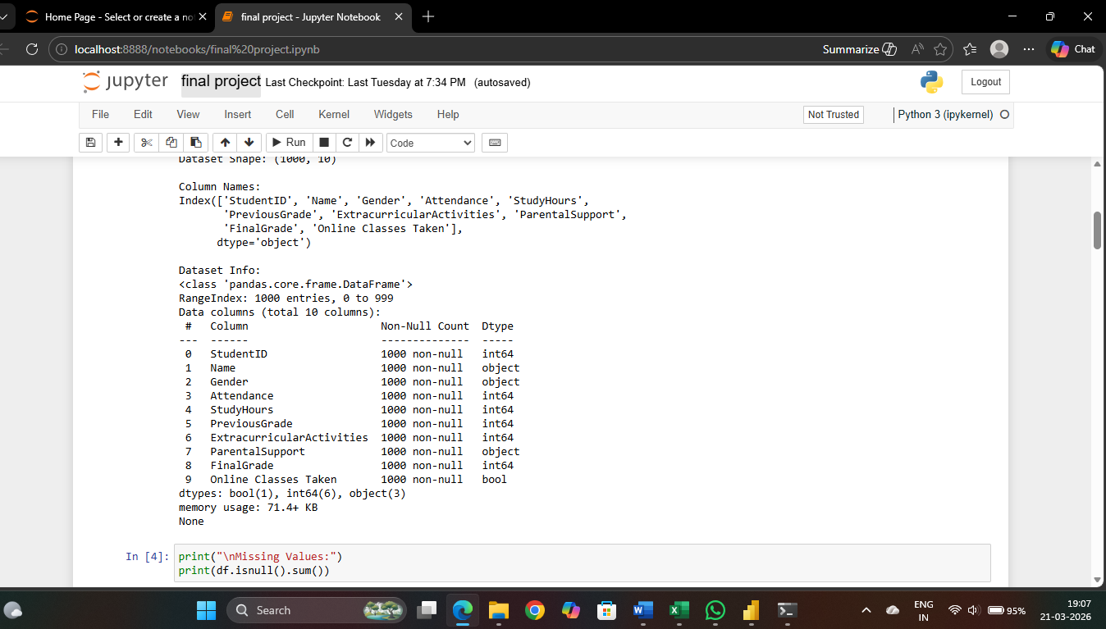

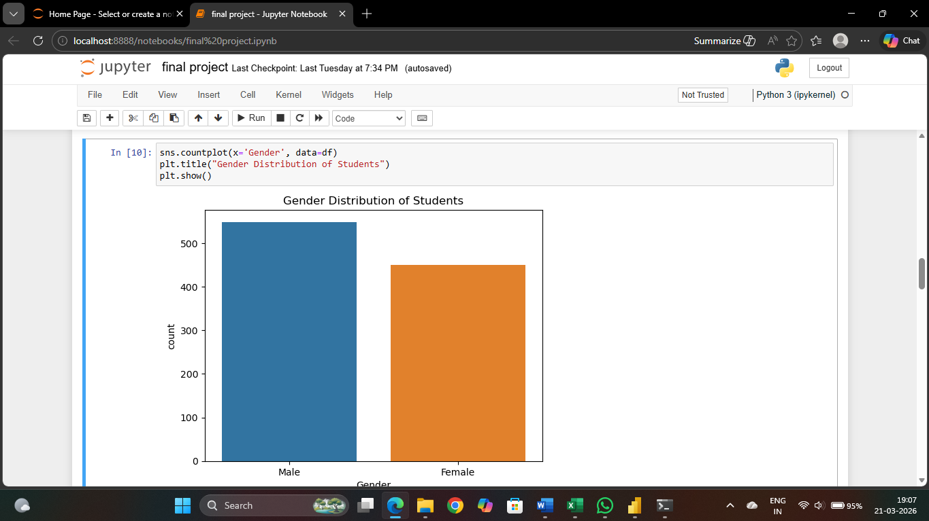

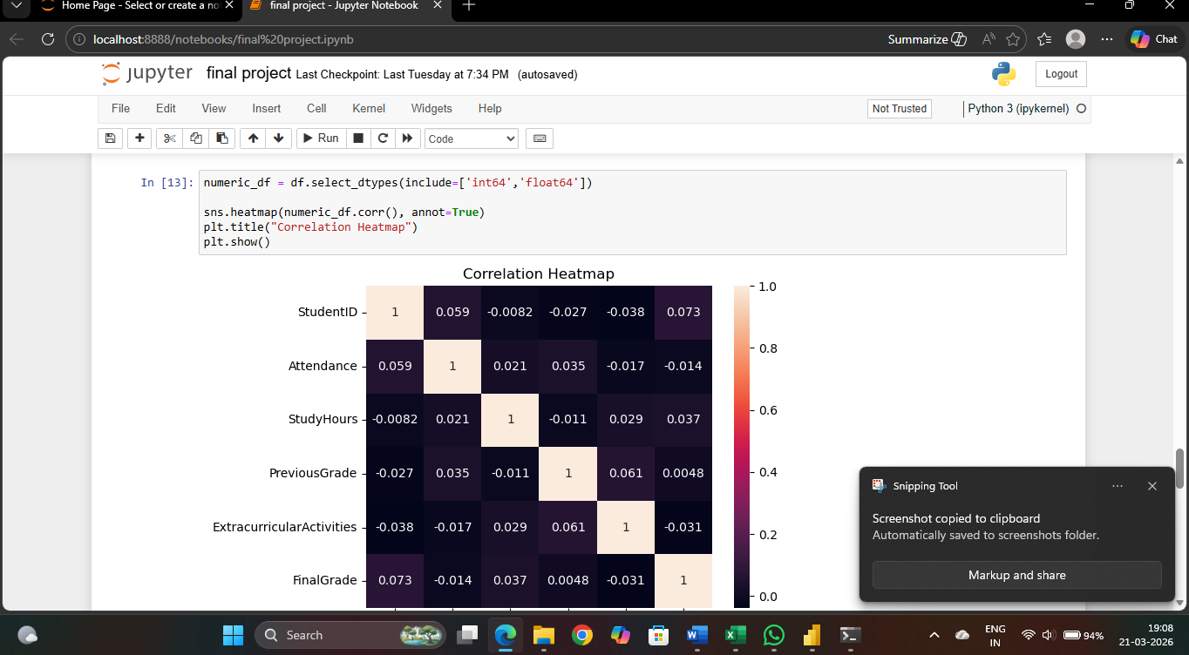

Tools Used :
Various tools and technologies were used in this project to perform data cleaning, analysis, and visualization effectively. Each tool played an important role in different stages of the data analysis process.

- SQL (Structured Query Language)
SQL was used for data extraction, cleaning, and exploratory data analysis. Queries such as SELECT, GROUP BY, HAVING, JOIN, and subqueries were applied to analyse relationships and generate insights from the dataset.
- Python
Python was used for data preprocessing and visualization. Libraries such as Pandas were used for data manipulation, while Matplotlib and Seaborn were used to create charts and graphs for better understanding of the data.
- Microsoft Excel
Excel was used for initial data inspection, basic cleaning, and formatting. It helped in quickly identifying missing values, duplicates, and inconsistencies in the dataset.
- Power BI
Power BI was used to create interactive dashboards and visualizations. It helped in presenting the analysis results in a clear and visually appealing manner, making it easier to interpret trends and insights.

Power BI Visualizations & Dashboard :
Power BI was used in this project to create interactive and visually appealing dashboards for better understanding of student performance data. The visualizations helped in identifying trends, patterns, and relationships between different variables.
The following visualizations were created:
- Bar Chart – Average Final Grade by Gender
This chart compares the average performance of students based on gender, helping identify any performance differences.
- Bar Chart – Average Grade by Parental Support
This visualization shows how different levels of parental support (High, Medium, Low) impact student performance.
- Scatter Plot – Study Hours vs Final Grade
This chart displays the relationship between study hours and final grades, helping to identify trends such as increasing performance with more study time and diminishing returns.
- Line Chart – Attendance vs Final Grade
This visualization shows how student performance changes with different attendance levels, highlighting the importance of regular attendance.
- Pie Chart – Extracurricular Activities Participation
This chart represents the proportion of students participating in extracurricular activities and helps analyse its impact on performance.
- Column Chart – Top 10 Students by Final Grade
This chart highlights the top-performing students, making it easy to identify high achievers.
- Clustered Bar Chart – Attendance Level vs Average Grade
Attendance was categorized into High, Medium, and Low, and this chart compares their average performance.
- Dashboard Overview
A comprehensive dashboard was created combining all key visuals, allowing users to interact with filters such as gender, attendance level, and parental support. This enables dynamic analysis and better decision-making.
Overall, Power BI visualizations made the data more understandable and helped in presenting insights in a clear, interactive, and professional manner.

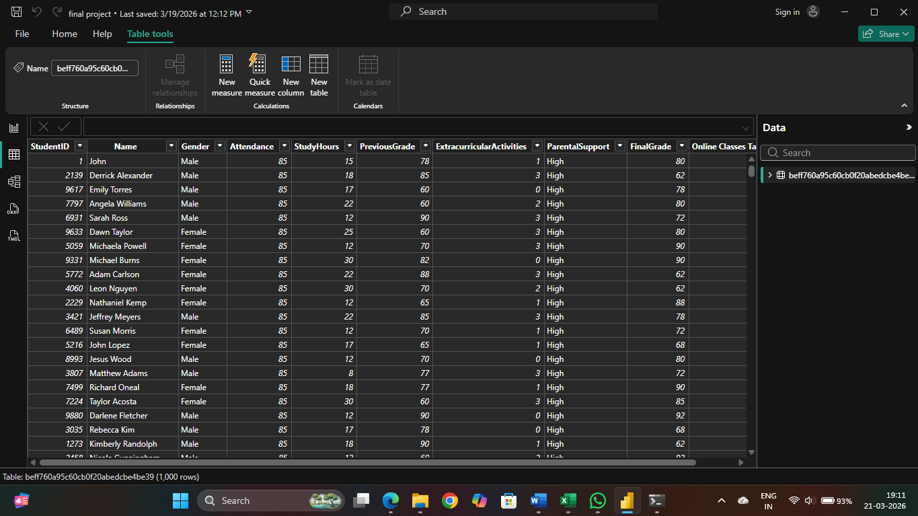

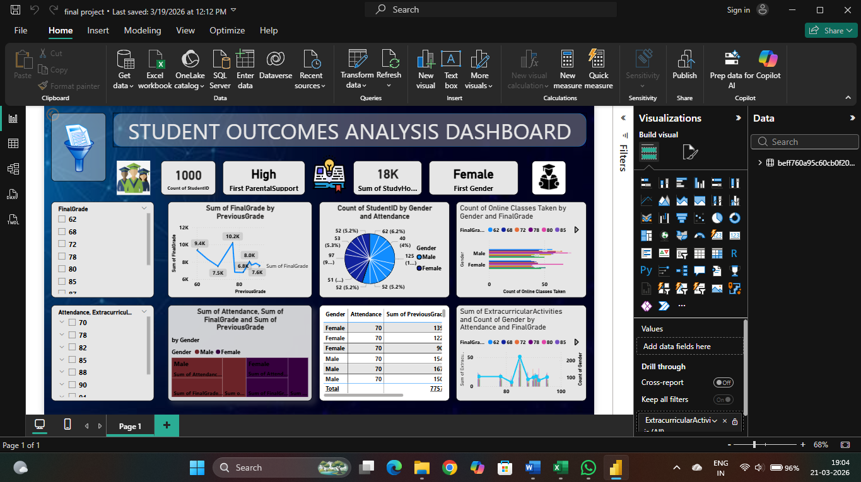

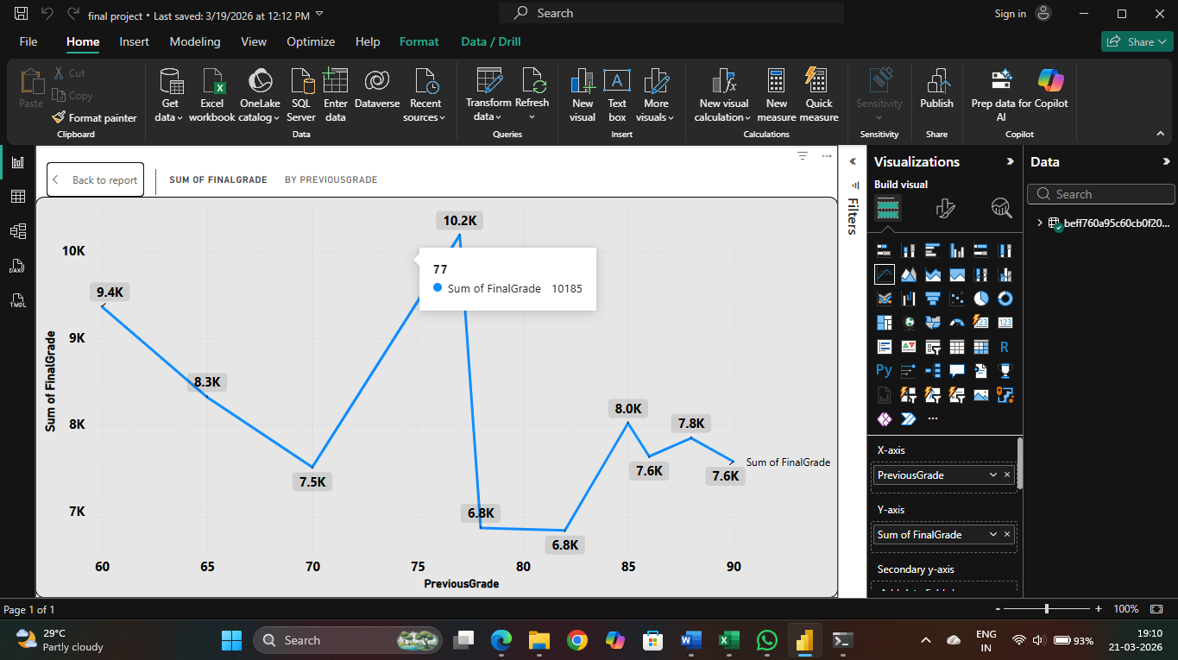

SQL Analysis :
SQL (Structured Query Language) was used in this project to perform data extraction, transformation, and analysis on the student performance dataset. Various SQL queries were applied to explore the data, identify patterns, and generate meaningful insights.
The following types of SQL operations were performed:
- Basic Data Retrieval
Simple queries using SELECT were used to view the dataset and understand its structure.
- Aggregate Functions
Function such as COUNT(), AVG(), and MAX() were used to calculate total students, average grades, and maximum study hours.
- Grouping and Summarization
The GROUP BY clause was used to group data based on categories such as gender, parental support, study hours, and attendance to analyze their impact on performance.
- Filtering with HAVING Clause
The HAVING clause was used to filter grouped data, such as identifying students with average grades above a certain threshold.
- Subqueries
Sub queries were used to perform advanced analysis, such as identifying students who scored above the average grade.
- Sorting and Ranking
The ORDER BY clause was used to rank students based on their final grades and identify top performers.
- Conditional Analysis using CASE Statement
A CASE statement was used to categorize attendance into levels (High, Medium, Low) and analyse performance across these categories.

Sample SQL Queries Used
Your project included queries such as:
- Total students count
- Average final grade
- Gender-wise performance
- Parental support impact
- Study hours vs performance
- Attendance-based analysis
- Top-performing students
- Above-average students (subquery)
- Attendance categorization using CASE
These queries helped in transforming raw data into structured insights and played a crucial role in the Exploratory Data Analysis phase.

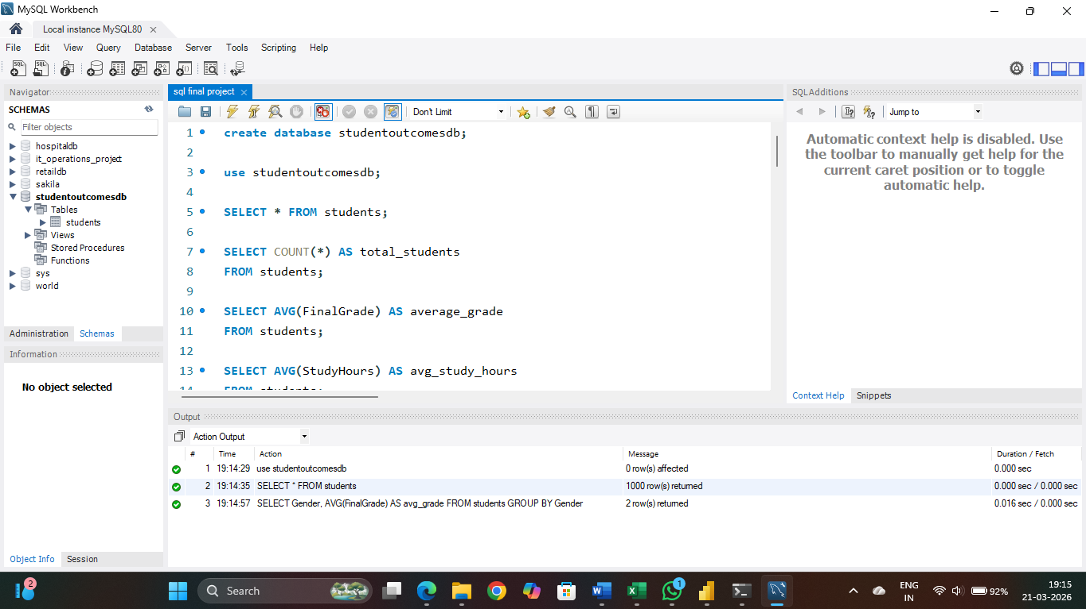

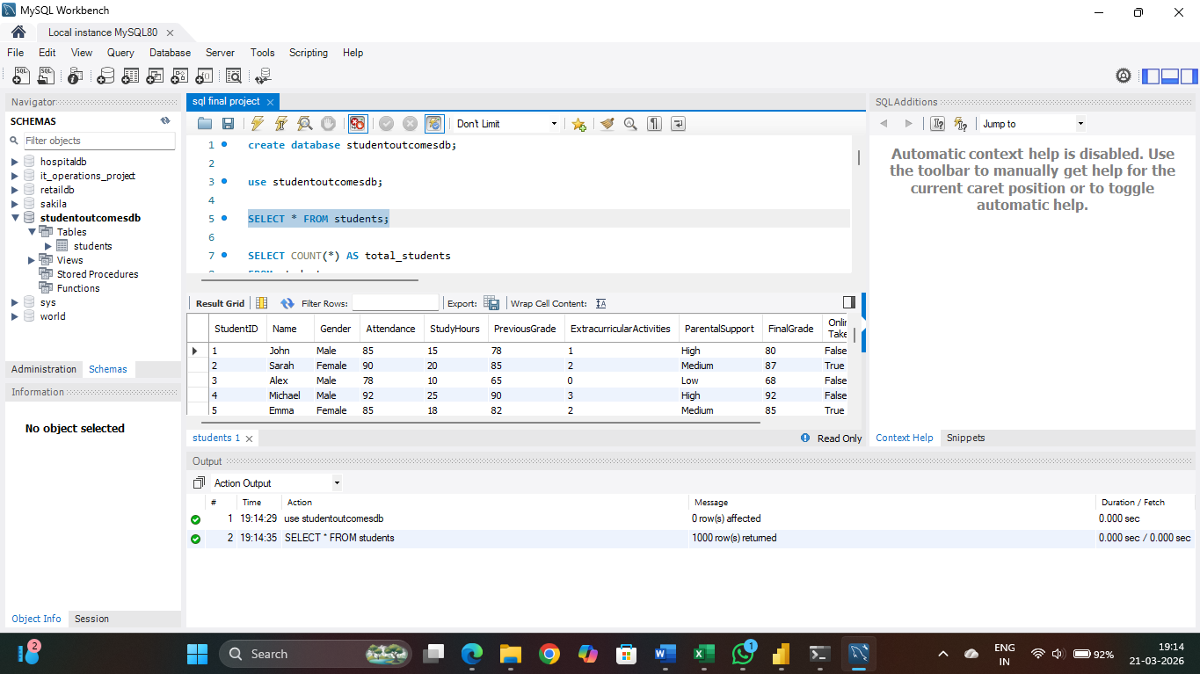

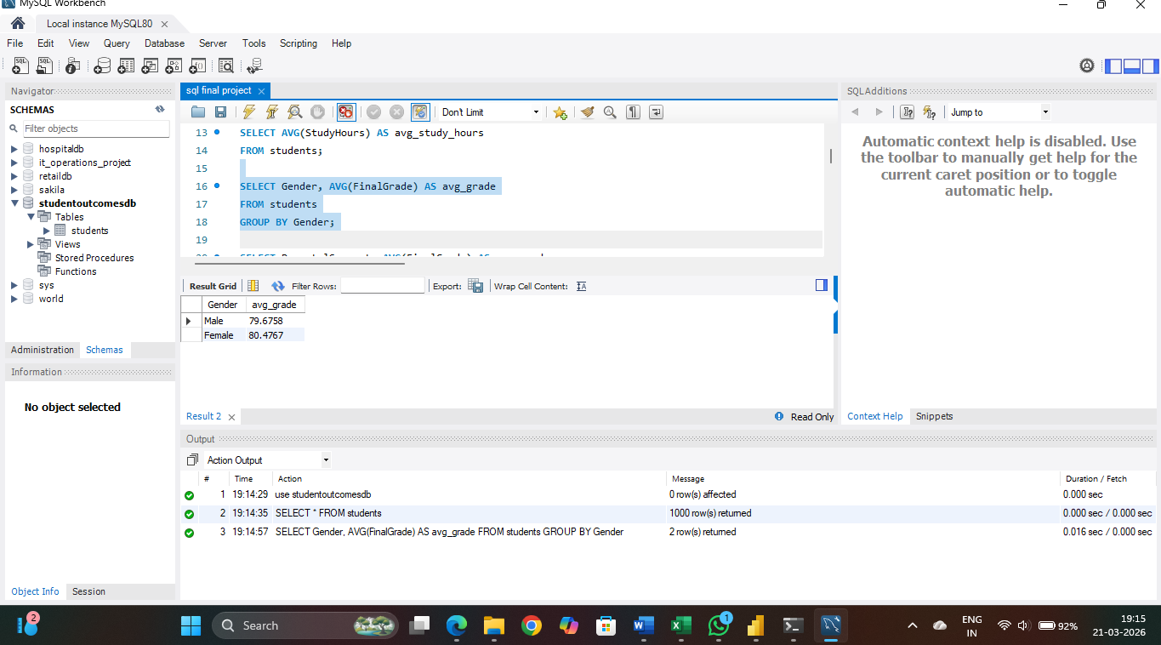

Key Insights :
- Study hours have a positive impact on performance, but after a certain limit, the improvement in grades becomes minimal (diminishing returns).
- Students with high attendance (above 90%) generally achieve better academic results compared to those with low attendance.
- Parental support plays a significant role in student success; students with high parental support tend to score higher grades.
- Some students perform well despite low study hours, indicating the influence of factors like prior knowledge or learning ability.
- There is no major performance gap between genders, showing that academic success is not gender-dependent.
- Students who balance both academics and extracurricular activities often perform better than those focusing only on studies.
- High study hours can sometimes compensate for lower attendance, but consistent attendance still provides an advantage.
- Students with both high study hours and high attendance achieve the best overall performance.
- A minimum attendance threshold is necessary to maintain good academic results.
- The dataset contains outliers, including both top performers and low performers, indicating variation in student capabilities.
- Previous academic performance has a strong influence on final grades.
- Students with low parental support and low study hours are more likely to have lower grades.
- Consistency in study habits is a key factor in achieving high academic performance.
- External factors such as environment and support systems significantly impact learning outcomes.
- Data analysis helps in identifying hidden patterns that are not easily visible through raw data.

Recommendations :
Based on the analysis of student performance data, the following recommendations are suggested to improve academic outcomes:
- Encourage Consistent Study Habits
Students should maintain regular study schedules instead of studying only during exams to achieve better results.
- Improve Attendance Levels
Educational institutions should emphasize the importance of attendance, as higher attendance is directly linked to better performance.
- Enhance Parental Involvement
Parents should actively support and monitor their children’s academic progress to boost performance.
- Promote Balanced Lifestyle
Students should be encouraged to participate in extracurricular activities along with academics to improve overall development and performance.
- Provide Support for Low-Performing Students
Special attention, mentoring, and remedial classes should be given to students who show low performance.
- Focus on Personalized Learning
Teaching strategies should be adapted to individual student needs, as not all students perform well with the same study patterns.
- Monitor Study Hours Effectively
Instead of only increasing study time, focus should be on effective and smart study techniques.
- Use Data-Driven Decision Making
Schools and colleges should use data analysis tools to regularly monitor student performance and take necessary actions.
- Set Minimum Attendance Policies
Institutions can implement attendance thresholds to ensure students remain engaged in learning.
- Encourage Continuous Assessment
Regular tests and feedback can help track student progress and improve performance over time.
Conclusion :
This project focused on analysing student performance data to identify the key factors that influence academic success. Through data cleaning, exploratory data analysis, and visualization, meaningful patterns and relationships were discovered within the dataset.
The analysis showed that factors such as study hours, attendance, and parental support have a significant impact on student performance. However, it was also observed that increasing study hours alone does not always guarantee higher grades, highlighting the importance of effective learning strategies and a balanced approach.
Additionally, the project demonstrated that consistent attendance and a supportive environment contribute positively to academic outcomes. The presence of outliers and exceptional cases indicates that individual differences also play an important role in performance.
Overall, this project highlights the importance of using data analysis techniques to make informed decisions in the education sector. The insights and recommendations provided can help educators, students, and institutions improve academic performance and achieve better results.

References :
- Student Performance Dataset – Kaggle
https://www.kaggle.com/
- Microsoft Documentation – SQL
https://learn.microsoft.com/en-us/sql/
- Python Documentation
https://docs.python.org/3/
- Pandas Library Documentation
https://pandas.pydata.org/docs/
- Matplotlib Documentation
https://matplotlib.org/stable/contents.html
- Seaborn Documentation
https://seaborn.pydata.org/
- Microsoft Power BI Documentation
https://learn.microsoft.com/en-us/power-bi/

